**Laboratory Report**

**On**

**Smart Vehicle Tracking System**

**(IOT Mini Project)**

**Submitted By-**

**Atika Chandel-21052406**

**Roshan Kumar-21052445**

**Tushar Anand-21052461**

**Mohammad Ruman-21052675**

**B.Tech Program in Computer Science and Engineering**

**School of Computer Engineering**

**Kalinga Institute of Industrial Technology, Deemed to be University**

**Bhubaneswar,India**

**April 2024**

**Report on Smart Vehicle Tracking Systems**

**Introduction**

Smart car tracking systems are a ground-breaking development in contemporary transportation technology that seek to maximize vehicle efficiency and safety while also enhancing vehicle security. These systems provide real-time tracking of vehicle locations and statuses through the seamless integration of hardware and software components, which has numerous advantages for users and stakeholders.

**Objective**

Multifaceted tracking systems for smart vehicles are their main goal. These systems aim to do more than just prevent car theft; they also want to optimize routes, save fuel, and offer critical fleet management analytics. By utilizing state-of-the-art technologies, they hope to raise the bar for operational effectiveness and vehicle safety.

**Requirement**

Because smart car tracking systems are so complicated, hardware and software components must work together harmoniously. Fundamentally, the hardware consists of GSM modules for smooth data transfer and GPS units for accurate location monitoring. Sophisticated software infrastructure, such as tracking servers and digital maps for visualization, is necessary to support this. The system's functionality is further improved by the incorporation of sensors to monitor vehicle factors like fuel levels, lights, doors, and ignition.

**Theory**

The underlying technologies of GPS and GSM are the foundation of smart car tracking systems. These systems use GPS receivers to triangulate signals from satellites in orbit to determine the location of the vehicle. GSM modules then make it possible for this location data to be transmitted in real-time to centralized servers or mobile applications, guaranteeing ongoing monitoring and analysis.

**Application**

Smart vehicle tracking systems have applications in many different fields, including fleet management and logistics. These technologies enable firms to save operational expenses, optimize routes, and reduce theft risks by offering unmatched visibility into transportation operations. Their versatility and essential role in contemporary transportation ecosystems is further demonstrated by their integration with parking systems, driverless vehicles, traffic management, and surveillance systems.

**Formula**

The calculation of GPS-derived coordinates is a common mathematical building block of intelligent car tracking systems. Formulas like $\left[f=\frac{1}{2π\sqrt{LC}}\right]$, which expresses the frequency of GPS signals, are an example of the complex computations that underlie the functionality of the system and allow for accurate location monitoring and analysis.

**Code**

#include<string.h>

#define DEBUG true

**int** PWR_KEY = 9;

**int** RST_KEY = 6;

**int** LOW_PWR_KEY = 5;

**String** msg = **String**("");

**int** SmsContentFlag = 0;

**String** mob;

**String** loct;

**void** setup()

{

  pinMode(PWR_KEY, OUTPUT);

  pinMode(RST_KEY, OUTPUT);

  pinMode(LOW_PWR_KEY, OUTPUT);

  digitalWrite(RST_KEY, LOW);

  digitalWrite(LOW_PWR_KEY, HIGH);

  digitalWrite(PWR_KEY, HIGH);

  SerialUSB.begin(115200);

  Serial1.begin(115200);

  delay(2000);

  SerialUSB.println("Checking Module...");

**int** i = 1;

**String** res;

**while** (i) {

    Serial1.println("AT");

**while** (Serial1.available() > 0) {

**if** (Serial1.find("OK"))

        i = 0;

    }

    delay(500);

  }

  SerialUSB.println("Module Connected");

  SerialUSB.print("Text Mode: ");

  i = 1;

**while** (i) {

    Serial1.println("AT+CMGF=1\r");

**while** (Serial1.available() > 0) {

**if** (Serial1.find("OK"))

        i = 0;

    }

    delay(500);

  }

  SerialUSB.println("ON");

  Serial1.println("AT+GPS=1");

  SerialUSB.println("GPS Intializing...");

  delay(5000);

  SerialUSB.println("GPS Initialized");

  SerialUSB.flush();

  i = 1;

**String** str;

**while** (i) {

    Serial1.println("AT+LOCATION=2");

    delay(100);

**while** (Serial1.available() <= 0);

**if** (Serial1.find("AT+LOCATION=2")) {

      str = Serial1.readString();

      i = 0;

    }

    delay(500);

  }

  loct = str.substring(4, 23);

  SerialUSB.print("Location: ");

  SerialUSB.println(loct);

  SerialUSB.println("Send sms to get the location");

}

**void** loop()

{

**char** SerialInByte;

**if** (Serial1.available())

  {

    SerialInByte = (**unsigned** **char**)Serial1.read();

**if** ( SerialInByte == 13 )

    {

      ProcessGprsMsg();

    }

**if** ( SerialInByte == 10 )

    {

    }

**else**

    {

      msg += **String**(SerialInByte);

    }

  }

**if** (SmsContentFlag == 1) {

**int** i;

    SerialUSB.println("Flag Cleared");

    SerialUSB.print("Message: ");

    SerialUSB.println(msg);

**if** (msg.indexOf("Location")) {

      SerialUSB.println("Message Received");

      i = msg.indexOf("+91");

      i = i + 3;

**for** (**int** j = 0; j < 10; j++, i++) {

        mob += msg[i];

      }

      SerialUSB.print("Mobile: ");

      SerialUSB.println(mob);

**String** cmd = "AT+CMGS=\"";

      cmd += mob;

      cmd += "\"";

      cmd += "\r";

      Serial1.println(cmd);

      delay(100);

      Serial1.print("Your Vehicle Current Location ");

      Serial1.print(loct);

      Serial1.print("\n");

      Serial1.print("Check Map: \n");

      Serial1.print(" https://www.google.com/maps/@");

      Serial1.println(loct);

      Serial1.println((**char**)26);

      delay(1000);

    }

    ClearGprsMsg();

    SmsContentFlag = 0;

    msg.remove(0);

    mob.remove(0);

  }

  delay(100);

}

**void** GprsTextModeSMS()

{

  Serial1.println( "AT+CMGF=1" );

}

**void** GprsReadSmsStore( **String** SmsStorePos )

{

  Serial1.print( "AT+CMGR=" );

  Serial1.println( SmsStorePos );

}

**void** ClearGprsMsg()

{

  msg = "";

}

**void** ProcessGprsMsg()

{

  SerialUSB.println("");

  SerialUSB.print( msg );

**if** ( msg.indexOf( "Call Ready" ) >= 0 )

  {

    SerialUSB.println( "*** GPRS Shield registered on Mobile Network ***" );

    GprsTextModeSMS();

  }

**if** ( msg.indexOf( "+CIEV" ) >= 0 )

  {

    SerialUSB.println( "*** SMS Received ***" );

  }

**if** ( msg.indexOf( "+CMT:" ) >= 0 )

  {

    SmsContentFlag = 1;

**return**;

  }

**if** ( SmsContentFlag == 1 )

  {

    SerialUSB.println( "*** SMS MESSAGE CONTENT ***" );

    SerialUSB.println( msg );

    SerialUSB.println( "*** END OF SMS MESSAGE ***" );

  }

}

**Tinkercad Structure**

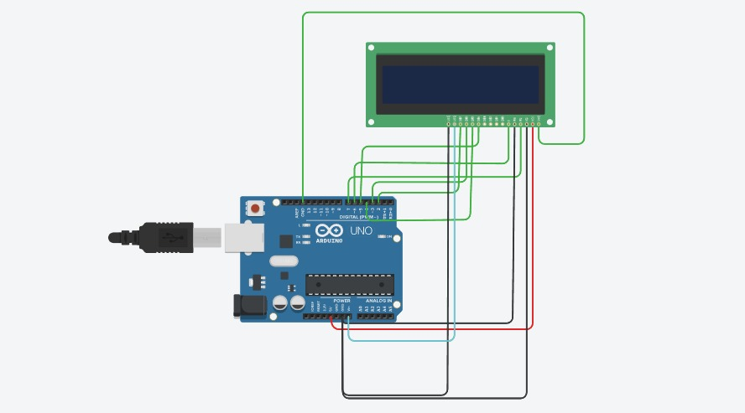

**Flow Chart**

**For Transmitter**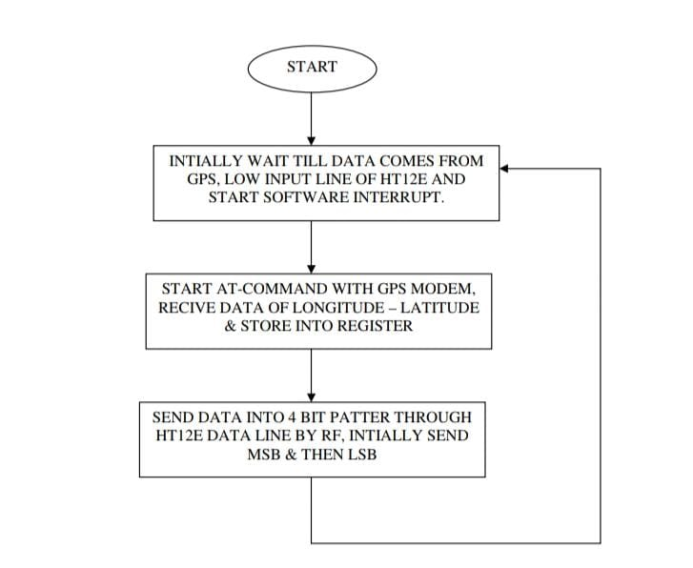

**For Receiver**

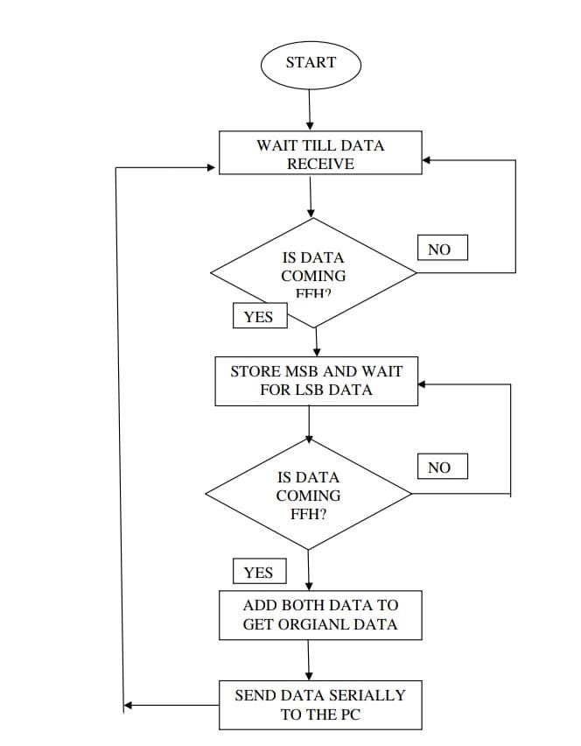

**Observation**

The capacity of smart car tracking systems to offer real-time insights into the whereabouts and statuses of vehicles is essential to their effectiveness. These technologies give users extraordinary control and situational awareness by constantly monitoring movement and quickly reporting irregularities, enhancing road safety and security.

**Discussion of Result**

The implementation of smart vehicle tracking technologies has yielded remarkably palpable results. Research continuously shows them to be superior to traditional tracking techniques, with notable gains in operating cost reduction, logistical efficiency, and theft avoidance. Furthermore, by improving fleet management procedures and road safety, these systems become essential resources for contemporary transportation companies.

**Conclusion**

In summary, smart car monitoring systems offer a comprehensive strategy for improving efficiency, security, and safety. They mark a paradigm leap in the field of transportation technology. Utilizing the latest developments in GPS, GSM, and sensor technologies, these systems are the perfect example of how hardware and software work together to optimize vehicle operations. With their increasing usage and the ongoing development of technical advances, the future is quite promising for smart vehicle monitoring system advancements that will transform the transportation scene.